Topic: 2018 Nunavut Food Price Survey
2017 - 2018 Price Differences of 24 Select Items, by Community
Released by the Nunavut Bureau of Statistics – September 2018

Background: In March 2018, the Nunavut Bureau of Statistics (NBS) conducted a food price survey in all 25 communities of Nunavut. Prices of 141 items, including 19 non-food items, were collected by Government Liaison Officers from all retail stores in the communities.

The chart below shows the percentage differences in the cost of 24 select food items between March 2017 and March 2018 across the territory. Generally, the averaged percentage price of 24 select food items in Nunavut increased marginally by 1.8% which contrasts with the slight percentage price drop (1.1%) experienced previously in 2016-2017. The highest percentage price increases for the period 2017-2018 were registered in Grise Fiord (16%), followed by Kugaaruk (14%), Baker Lake (11%) and Rankin Inlet (10%). On the other hand, price reductions were observed in approximately half of the communities during this period. The highest price decrease of 8% was encountered in Hall Beach while Taloyoak had the second highest decrease (6%). A few of the communities recorded relatively low price declines of less than 2%. They include Arviat, Qikiqtarjuaq, Naujaat, Cambridge Bay, Whale Cove and Gjoa Haven. Chesterfield Inlet which posted the highest price increase during the previous 2016-2017 period registered no price changes during 2017-2018, thus maintaining the same price levels over the years. Iqaluit, the territorial capital and largest settlement in Nunavut recorded a percentage price rise of 6% in 2017-2018. A number of variables partially explain the differential food price levels in Nunavut. They include fluctuating food availability in communities that result from periodic supply interruptions which in turn emanate from weather-related flight disruptions, the small number of communities covered in the survey and the consecutive year to year price variations. Visual details about the varying average food price levels in the communities are available in the chart below.
Details:
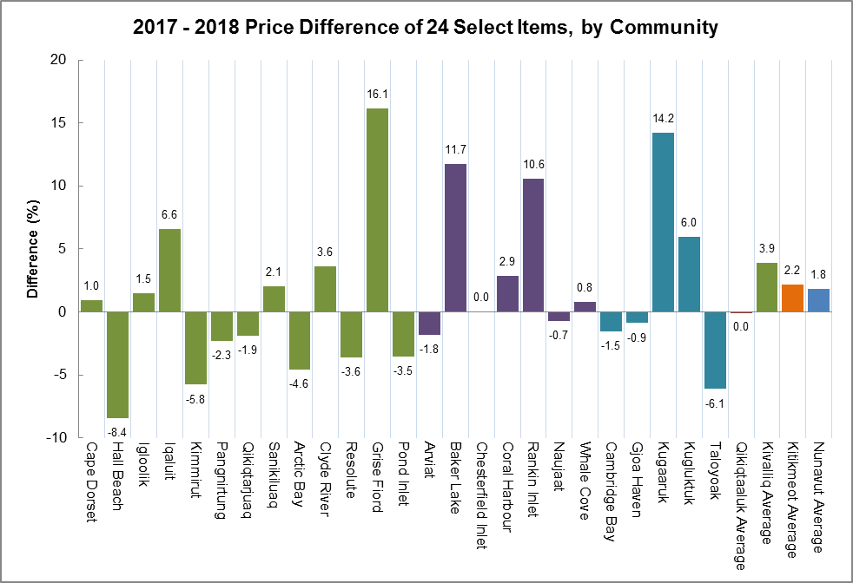

Notes:
1. The 24 Select Food Items Basket includes: 2% Milk (2L), Apples (1kg), Baby Food in Jars (128ml), Bananas (1kg), Canned Baked Beans (398ml), Canned Cream of Mushroom (284ml), Canned Pink Salmon (213g), Carrots (1kg), Eggs (12 Large), Frozen Corn (750g), Frozen French Fries (650g-1kg), Frozen Pizza (One Unit, >799g), Ground Beef (1kg), Instant Rice (700g), Macaroni and Cheese Dinner (200-225g), Margarine (454g), Pork Chops (1kg), Potatoes (2.27kg), Quick Oatmeal (900g-1kg), Soda Crackers (450g), Spaghetti Noodles (500g), White Bread (570g), White Flour (2.5kg), Wieners (450-500g).
2. Nunavut price is the average price of each selected item for all reporting Nunavut communities.
3. Prices were collected in March of 2017 and 2018.
4. For the complete tables showing food prices for all 25 Nunavut communities, see the release – “2017-2018 Nunavut Food Price Survey, Comparison of 24 Select Food Items Basket” by visiting the Nunavut Bureau of Statistics Website at: https://livehealthy.gov.nu.ca/en/healthy-eating/nunavut-food-guide

